PHASE – 3
Solution Planning
- Purpose
After completing the requirement gathering and feasibility analysis, the next step is to develop a detailed implementation strategy for the OpenStack production environment. This phase establishes the deployment sequence, infrastructure planning, configuration standards, network allocation, storage planning, and operational guidelines that will be followed during the implementation phase.
The purpose of this phase is to ensure that every infrastructure component is planned in advance to minimize deployment risks and provide a structured roadmap for building the production cloud environment.

Planning Scope
The planning activities cover the following areas:
  - Production infrastructure planning
  - OpenStack service planning
  - Cluster architecture planning
  - Network segmentation planning
  - Storage architecture planning
  - High Availability planning
  - Security planning
  - Capacity planning
  - Deployment sequencing
  - Configuration management planning

Infrastructure Planning
The production environment will be built using eight physical servers. Instead of assigning services randomly, each node will be planned according to its functionality to improve availability, simplify maintenance, and balance workloads.
Planned Infrastructure Layout

Node Category Planned Quantity
Primary Purpose

Controller + Ceph 3 OpenStack Control Plane and Ceph Monitor Services Dedicated Ceph 1 Distributed Storage Services
Compute 4 Virtual Machine Hosting

OpenStack Service Planning
The required OpenStack services are grouped according to their operational functionality.

Service Group Planned Services
Identity Services Keystone
Compute Services Nova
Networking Services Neutron
Image Services Glance
Storage Services Cinder
Dashboard Services Horizon
Placement Services Placement
Orchestration Heat (Future Expansion)
Monitoring Planned for Future Integration

Cluster Planning
The cluster will be designed to eliminate single points of failure by distributing critical services across multiple controller nodes.

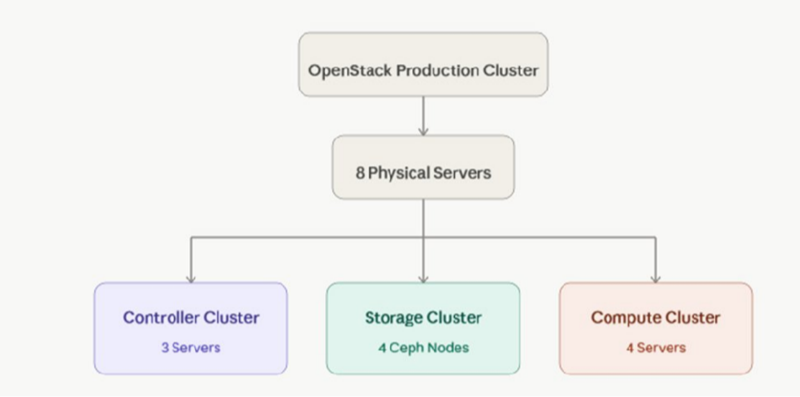
Cluster Planning Overview

Network Planning Strategy
To ensure traffic isolation and improve performance, each type of communication will use a dedicated network.

Planned Network Usage

 | Network | Planned Traffic
Out-of-Band |  | Remote Server Management
Management |  | Server Administration
Public API |  | External API Requests
Private API |  | Internal OpenStack Communication
Tunnel |  | VXLAN Traffic
Self-Service |  | Tenant Virtual Networks
Storage Public |  | Client Access to Ceph
Storage Cluster |  | Ceph Replication
External |  | Floating IP Traffic
Enterprise iSCSI |  | SAN Connectivity
Enterprise NAS |  | Shared Storage

IP Address Planning
Each network will have its own subnet to simplify routing, improve security, and reduce broadcast traffic.

 | Network | Sample Subnet
Management |  | 192.168.10.0/24
Public API |  | 192.168.20.0/24
Private API |  | 192.168.30.0/24
Tunnel |  | 192.168.40.0/24
Storage Public |  | 192.168.50.0/24
Storage Cluster |  | 192.168.60.0/24
External |  | Organization Public Network
iSCSI |  | 192.168.70.0/24
NAS |  | 192.168.80.0/24
Note: The final IP addressing scheme will be assigned according to the organization's network standards during implementation.

Storage Planning
The storage design is planned to support both internal distributed storage and future enterprise storage integration.

Storage Planning Matrix
Storage Component Planned Backend
VM Disks Ceph RBD
Image Repository Ceph
Block Storage Ceph
Backup Storage Ceph
Enterprise SAN iSCSI
Enterprise File Storage NAS

High Availability Planning
To maintain service continuity during hardware or software failures, redundancy is incorporated into the architecture.

Component Planned HA Solution
API Access HAProxy + Keepalived

Database MariaDB Galera Cluster
Message Queue RabbitMQ Cluster
Storage Ceph Replication
Controllers Multi-Controller Deployment

Configuration Planning
Before deployment, configuration standards will be finalized to maintain consistency across all nodes.

Configuration Items
  - Standard hostname naming convention
  - Network interface mapping
  - Docker configuration
  - Python environment
  - Kolla-Ansible inventory structure
  - Global configuration parameters
  - TLS certificate configuration
  - DNS and NTP configuration

Validation Planning
The deployment will not proceed to production until all planned validation checks are completed successfully.

Planned Validation Activities
Validation Area Expected Outcome Network Connectivity All nodes communicate successfully API Availability OpenStack APIs are accessible
Storage Availability Ceph cluster reports healthy status Compute Registration All compute nodes join the cluster Image Upload Images can be uploaded successfully
Volume Creation Cinder volumes are created successfully
Instance Launch Virtual machines boot successfully
Floating IP External connectivity is verified

